Changing Tray Paper Size – Ricoh IM C300
These instructions will guide you through the process of changing the tray size on the printer when placing different size paper in the tray(s).
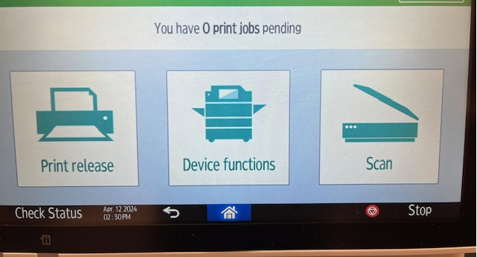
- To change size, select Device functions

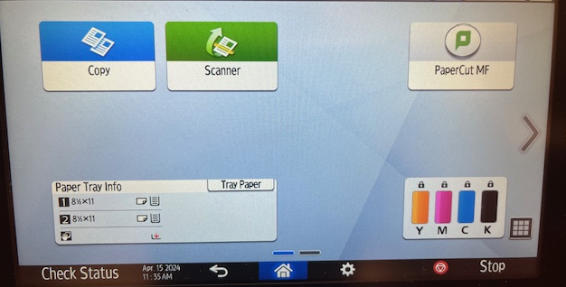
- Select Tray Paper

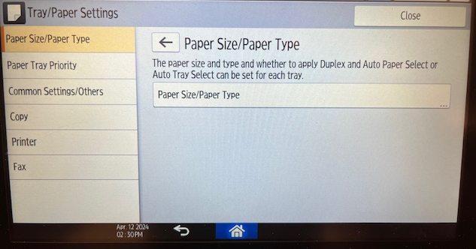
- Select Paper Size/Paper Type

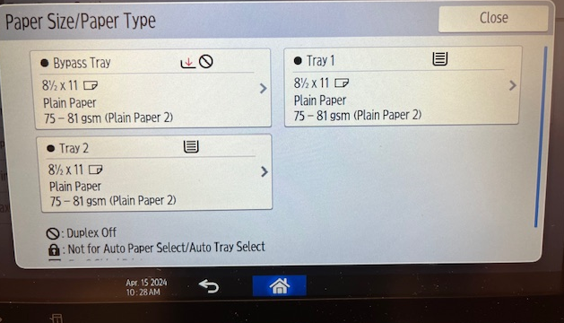
- Select the Tray the new size paper was added
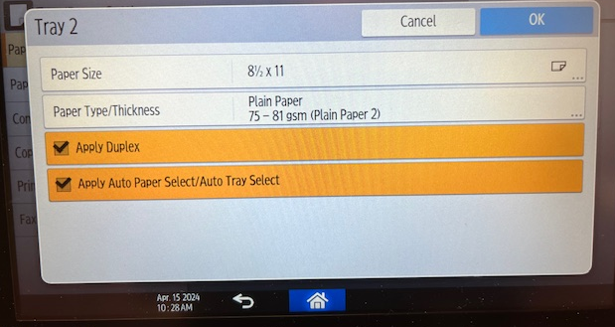
- Select Paper Size
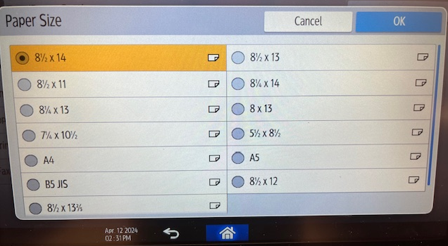
- Select new Paper Size, then select OK

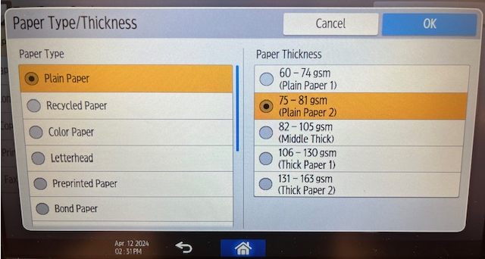
- Select Paper Type/Thickness, then select OK
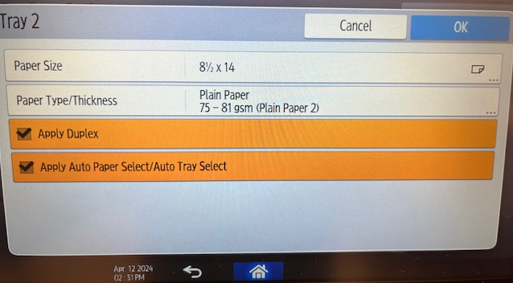
- Select OK if the changes are correct. If incorrect, back arrow to step 6.
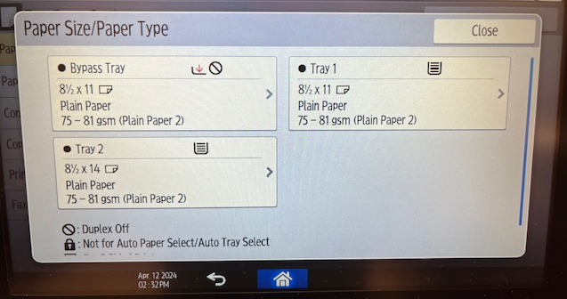
- Verify the Paper Tray size is correct and select the Home icon at the bottom

