Ricoh IM C300
Non-Standard paper printing using the Bypass Tray
These instructions will provide you the steps to setup the Ricoh printer and PaperCut print driver to print envelopes, labels, letterhead or other specialty items using the side bypass tray.
- From a Microsoft Word document - Select File_Print_Printer Properties
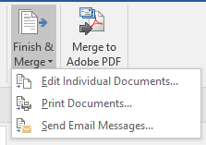
NOTE: If printing merged data files under the Mailings tab select Finish & Merge then Print Documents…

- Before printing from your device change the printer settings under Print Properties
a. Document Size: see below
b. Input Tray: see below
c. Paper Type: see below
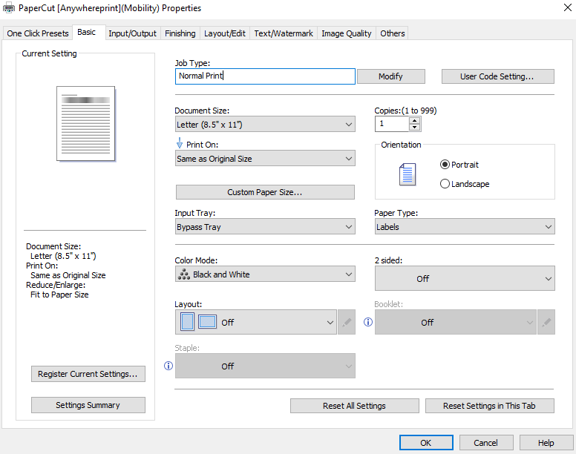
d. Check that Orientation is set to your preference

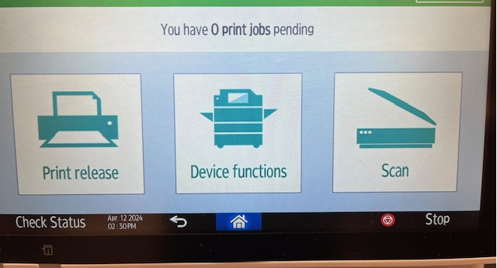
- To change paper size, select Device functions

- Select Tray Paper
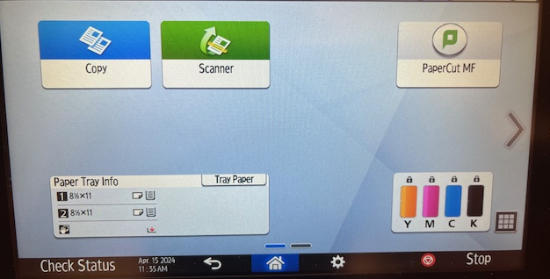

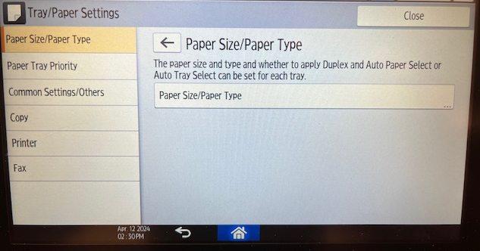
- Select Paper Size/Paper Type

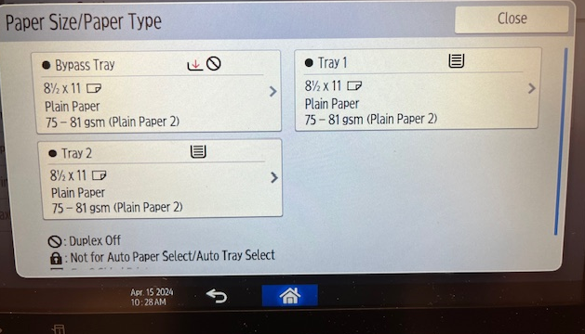
- Select the Bypass Tray

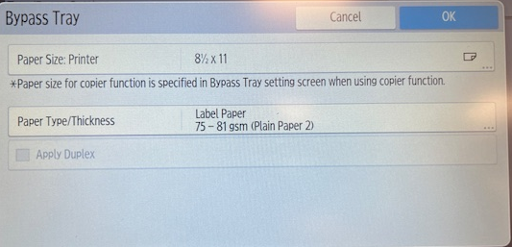
- Select Paper Size

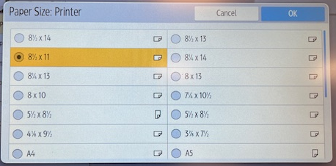
- Select new Paper Size, then select OK

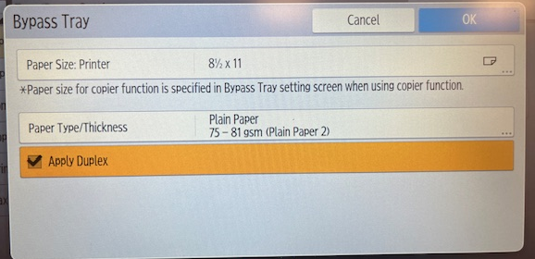
- Select Paper Type/Thickness

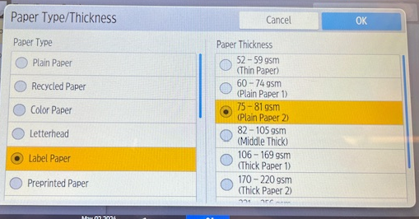
- Select new Paper Type/Thickness, then select OK

- Select OK if the changes are correct. If incorrect, back arrow to step 6.
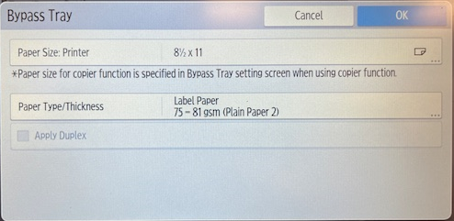

- Verify the Paper Tray size is correct and select the Home icon at the bottom
- Load your paper into the Bypass Tray
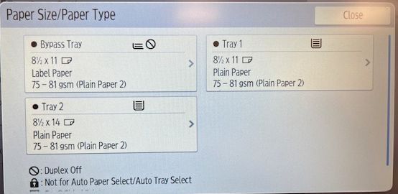
- Proceed with Releasing the job from PaperCut

Caution: Depending on the merged data the “RED” error light may come on at the printer requiring verification the correct paper type is placed in the bypass tray. If the light comes on proceed to the next steps:

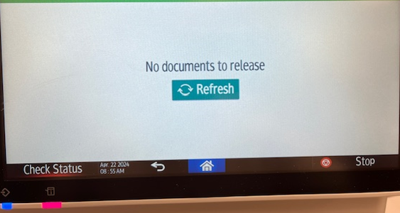
- Select Check Status on the screen

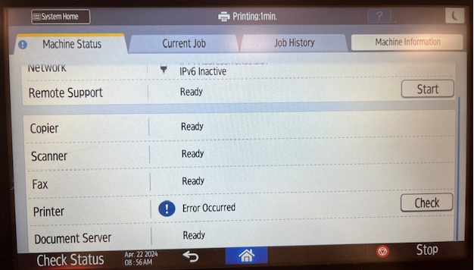
- Scroll down and under Printer select Check

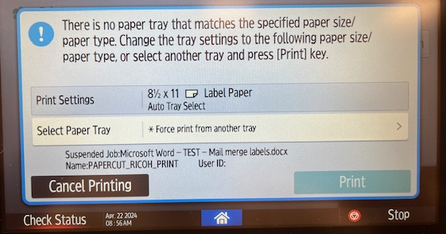
- Select *Force print from another tray

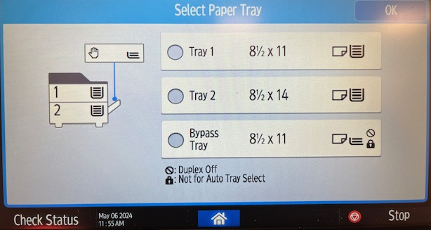
- Scroll down and Select Bypass Tray and OK

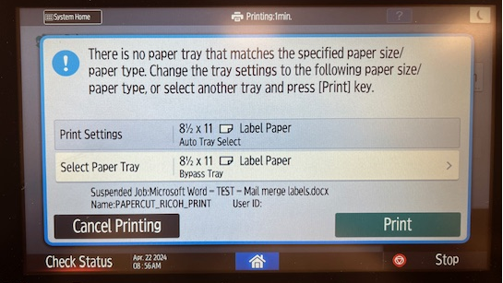
- Select Print

