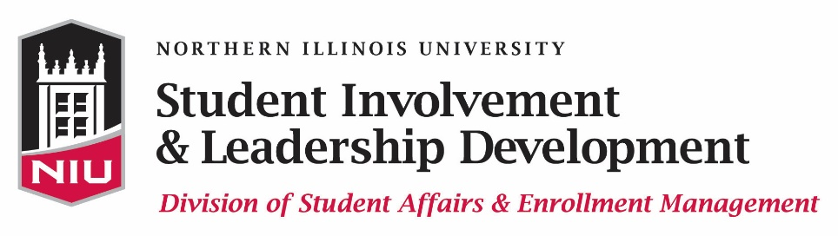

WHO’S WHO AMONG STUDENTS IN AMERICAN UNIVERSITIES AND COLLEGES

Instructions Form

In order to nominate a student for the Who’s Who Among Students in American Universities and Colleges, complete the nomination form within Huskie Link, our student organization database. The Who’s Who Among Students in American Universities and Colleges nomination form can be found at www.leadershipawards.niu.edu.The online nomination form must be submitted by 11:45 p.m. on Monday, February 13, 2017 in order for the student you are nominating to be eligible for this award.

PLEASE COMPLETE ALL PARTS OF THE APPLICATION IN ONE SITTING in order to avoid losing your data! This will ensure an accurate and timely application process.

Who's Who Among Students in American Universities and Colleges is a national college student recognition program in the United States. Students are honored based on outstanding campus leadership, scholastic ability, leadership on and off campus, and community service. Nominators will be asked to focus on these areas when describing why the nominee deserves this honor.
A nominee for inclusion in Who’s Who is required to be enrolled at Northern Illinois University during the current semester as a Junior, Senior, or Graduate student and must be expected to obtain a degree any time between December 2016 and May 2018. Students who previously have been named to Who’s Who are not eligible for consideration.
Be sure to complete the online Who’s Who nomination form by 11:45 p.m. on Monday, February 13, 2017. The Who’s Who nomination form can be found at www.leadershipawards.niu.edu.

If you have questions regarding the application process, please contact us at leadership@niu.edu or 815-753-6707.

