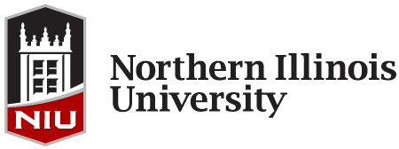

NIU WOMEN’S CLUB VOLUNTEERISM AWARD

Instructions Form

In order to apply for the Women’s Club Volunteerism Award, complete the Women’s Club Volunteerism Award application and upload all appropriate documents within Huskie Link, our student organization database. The link to the Women’s Club Volunteerism Award application can be found at www.leadershipawards.niu.edu. The online application and one statement of support must be submitted by 11:45 p.m. on Monday, February 13, 2017 in order to be eligible for this award.

The NIU Women’s Club Volunteerism Award will be given to an undergraduate woman who has volunteered her time and talents to worthy causes of her own choosing. This annual award, which includes a modest honorarium, was established and first presented in 1988 by the members of the University Women’s Club who wanted to show support in a special way to an outstanding female student who has learned the intangible rewards of volunteer service.

PLEASE COMPLETE ALL PARTS OF THE APPLICATION IN ONE SITTING in order to avoid losing your data! This will ensure an accurate and timely application process.

ELIGIBILITY/CRITERIA:
- Applicant must be a full-time undergraduate woman who has completed volunteer work.

MATERIALS NEEDED:
- Completed online application.
- A short statement of support from a representative of the agency or cause for which you have volunteered (submitted via the online application; you MUST upload this statement to your application yourself – please do not have your statement writer send the statement separately).
- Within the application, you must be prepared to articulate volunteer activities that you have been involved in for charitable or humanitarian service while being a student at NIU.
- Within the application, you also must be prepared to include a short statement about what you feel you have learned from your efforts and/or how it contributed to the agency/cause you volunteered for.

APPLICATION PROCESS AND DEADLINE:
- Complete the Women’s Club Volunteerism Award application and upload a short statement of support by 11:45 p.m. on Monday, February 13, 2017.

RECOGNITION:
- Email notification regarding this award will be available by early April 2017.
- Recipients will be honored at the Kevin D. Knight Leadership Awards Ceremony on Sunday, April 30, 2017.

If you have questions regarding the application process, please contact Victoria Nay at vnay@niu.edu or 815-753-8441.

