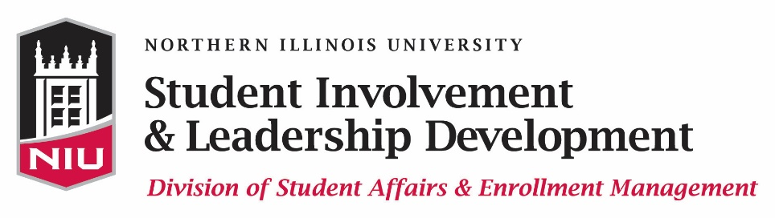

OUTSTANDING STUDENT ORGANIZATION AWARD

Instructions Form

In order to apply for the Outstanding Student Organization Award, complete the Outstanding Student Organization application and upload all appropriate documents within Huskie Link, our student organization database. The link to the Outstanding Student Organization Award application can be found at www.leadershipawards.niu.edu. The online application, two letters of recommendation, and an organization roster must be submitted by 11:45 p.m. on Monday, February 13, 2017 in order to be eligible for this award.

Student Involvement & Leadership Development recognizes the contributions of student organizations with its Outstanding Student Organization Award. An Outstanding Student Organization is one that exhibits teamwork, communication, effective management, high levels of performance, involvement with the University, and more. We are seeking applications of qualified organizations to be presented with this award at the Kevin D. Knight Leadership Awards Ceremony on Sunday, April 30, 2017.

PLEASE COMPLETE ALL PARTS OF THE APPLICATION IN ONE SITTING in order to avoid losing your data! This will ensure an accurate and timely application process.

ELIGIBILITY:
- The student organization must be a recognized student organization in good standing with the Office of Community Standards & Student Conduct, Registration & Records, Student Involvement & Leadership Development, Accounts Receivable, the Student Association, the NIU Department of Police & Public Safety, etc.

MATERIALS NEEDED:
- Completed online application
- Two letters of recommendation from the organization President and the organization Advisor (submitted via the online application; you MUST upload these within the online application – please do not have your recommendation writers send the letters separately)
- Organization roster (submitted via the online application; you MUST upload the roster within the online application – please do not send the roster separately)

CRITERIA:
The organization will be asked to describe the following in their online application:
- Leadership Skills (Teamwork and collaboration, diversity in programming, effective communication, management of Executive Board and members)
- Performance of Student Organization (Creative programs that fulfill the mission of the organization, creating an open and inclusive environment for members)
- University Involvement (Positive attitude toward NIU, increasing the quality of student life on campus, furthering the university mission and vision, participation in campus wide events)

APPLICATION PROCESS AND DEADLINE:
- Complete the Outstanding Student Organization Award application and upload your organization roster and two letters of recommendation no later than 11:45 p.m. on Monday, February 13, 2017
- All materials must be turned in simultaneously
- Incomplete nominations will not be considered

RECOGNITION:
- Email notification regarding this award will be available by early April 2017
- Recipients will be honored at the Kevin D. Knight Leadership Awards Ceremony on Sunday, April 30, 2017

If you have questions regarding the application process, please contact us at leadership@niu.edu or 815-753-6707.

