Academic Support Unit Assessment
Guidelines and Template

Submitted to the University Assessment Panel
AY 2021-2022

Academic Support Unit Assessment

GENERAL DIRECTIONS
Each academic support unit will submit two documents: (1) an updated assessment plan and (2) a status report detailing current and prior assessment efforts. The assessment plan describes the who, what, when, and where of the assessment system—it is forward thinking. The status report spells out what has happened in the past based on the previous assessment plan and what changes are being proposed. It should be noted that assessment plans evolve, meeting current and projected needs; revision to the assessment plan is to be expected.
Detailed directions with examples are provided in separate templates that follow and can also be found on our website at: https://www.niu.edu/effectiveness/assessment/support-unit.shtml
RATIONALE
Each academic support unit within the Division of Academic Affairs is guided by a mission statement and set of goals and objectives. These give purpose to the day-to-day operations of the unit, which ideally further and advance student successes. To foster continuous improvement efforts, support units regularly collect data on the degree to which they are meeting unit goals and objectives. Every five years, each academic support unit submits an updated assessment plan and a status report documenting assessment and program improvement activities. This provides an opportunity for academic support units to share assessment results—and receive constructive feedback and support for their assessment system.
University Assessment Panel members and Accreditation, Assessment and Evaluation staff will review the updated assessment plans and status reports, noting strengths in the assessment system and offering suggestions for improvement where appropriate. Feedback from peers and colleagues has led many programs and units to improve efficiencies and effectiveness. The university uses this peer feedback to provide tailored support to individual academic support units and to the university as a whole. Having an effective and efficient assessment system will go a long way in supporting student successes.

Academic Support Unit Assessment
Part I: Assessment Plan Explained
The assessment plan for academic support units begins with an introduction that includes a history of the unit and a description of the unit’s major responsibilities, programs, and products. This is followed by a mission statement, set of unit goals (each with underlying objectives), and a description of the assessment methods that will be used to determine whether the goals are being met. Target performance levels are set for each assessment method, along with a timeline indicating when each assessment will be carried out and who is responsible for carrying it out. The assessment plan is forward thinking.
The general format for the assessment plan is:
Cover Page
1. History and Context
2. Mission, Goals and Objectives
3. Assessment Methods
Explanation of Assessment Methods Table
Assessment Methods-by-Outcomes Matrix

The cover page for the assessment plan follows on the next page.

Part I: Assessment Plan
[Insert Unit Name]
[Insert Date of Plan]

Submitted to the University Assessment Panel by:
Insert Name and Title of Person Submitting Plan
1. History and Context of Unit Mission
Describe the history of the unit in enough detail to provide a contextual background that helps to clarify the unit’s mission, especially as it relates to the unit’s contributions to the university and student success. Include a description of major unit responsibilities, programs, and products.
Insert history and context here.
2. Mission, Goals and Objectives
List the unit’s mission statement, goals, and objectives in the appropriate spaces provided below. See the UAP Academic Support Unit Assessment Plan and Status Report Rubric-Checklist for a list of characteristics often seen in well-crafted mission statements, goals, and objectives. It is not expected that all characteristics are present, but that essential ones are, such as:
- mission clarifies the unique role of the unit and helps to differentiate the unit from similar units,
- unit goals focus on unit effectiveness and student learning outcomes (where appropriate),
- a sufficient number of goals to carry out the mission of the unit (3-5 is manageable), and
- a sufficient number of objectives per goal to operationalize and guide the attainment of each goal (2-4 objectives per goal is manageable).
The aim is to continually improve goals and objectives over time. Challenge your unit to move from product/process outcomes to student learning outcomes, as relevant. Take the next step.
Mission Statement
Insert the unit’s mission statement here.
Unit Goals and Objectives
Insert the unit’s goals and objectives here, using a format similar to the illustrated examples below:
Goal 1. Accreditation, Assessment and Evaluation will manage and coordinate university-wide assessment initiatives that meet the needs of multiple stakeholders while promoting continuous quality improvement of student learning.
Objective 1.1. The assessment programs of academic degree programs and support units will be of high quality, demonstrating: clear, appropriate, and measureable student learning outcomes; appropriate direct and indirect assessment methods that address all student learning objectives on a regular basis; effective data analysis, interpretation, and reporting; and appropriate use of results for continuous improvement efforts.
Objective 1.2. AAE will manage major university-wide assessment initiatives efficiently by acting on opportunities to constrain costs or improve efficiencies (i.e., increase impact for the same cost). Repeat same pattern for identifying other goals and objectives.
3. Assessment Methods
This final section of the assessment plan describes the assessment methods your unit is using to measure how well the unit is meeting its goals. See the UAP Academic Support Unit Assessment Plan and Status Report Rubric-Checklist for a description of characteristics seen in well-functioning assessment methods. Make sure the first three criteria are addressed. Aim for more than one direct assessment method per goal; one or more assessments per objective should suffice.
Explanation of Assessment Methods table
The first part of the assessment methods section is a description of each assessment method you will use. The description of each assessment needs to be in enough detail to communicate to others what the assessment is, what the desired target level of performance is on the assessment (to gauge if the unit is meeting the goal or goals), when the assessment will be given, and who is responsible for carrying out the assessment. See the UAP Academic Support Unit Assessment Plan and Status Report Rubric-Checklist for a list of characteristics seen in well-devised assessment methods.
Below is an example of a table you may use to clearly communicate each of the assessment methods to other stakeholders.
Assessment Method | Explanation
 | Description | Assessment-Level Target ª | When Data Will be Collected | Person Responsible | Goal(s)/objective(s) addressed:
Example 1: Annual Assessment Update Report | An authentic assessment of the quality of degree program assessment activities conducted over the past year. Degree programs annually report on data collection, analysis, and use of results for two program student learning outcomes. A rubric is used to assess the quality of the assessment activities, with a focus on clear and appropriate student learning outcomes, appropriate direct and indirect assessment methods, effective data reporting, and appropriate use of results for continuous improvement efforts. | All degree programs are at the Proficient level in all areas (student learning outcomes, assessment methods, time-frame and responsibilities, reporting results, and use of results). | Data is collected in the spring, report written in summer | Associate Director | Goal 1, obj. 1.1
Example 2: XYZ Event Participation Survey | Insert a brief description in enough detail for an outside reader to get a picture of the assessment method. For example, describe the XYZ Event Participation Survey- be specific about which items provide information related to individual goals/objectives. Attach all instruments, surveys, reports, etc. | Insert the target level of performance on the assessment e.g., x% of participants indicate an average rating of 4 or above on a 5 point scale for specific items | Insert when the data will be collected. | Insert the title of the person responsible for assessment. | Insert the goals/objectives addressed
Example 3: Trends in graduation and retention rates of participants in specific programs e.g., mentoring program, ABC Center | … | … | … | … | …
Note. ª Assessment-level target is the level of performance the unit hopes to see on the assessment (e.g., 85% percent of participants demonstrate X, Y, and Z).

ASSESSMENT METHODS-BY-OUTCOMES MATRIX
The assessment methods section concludes with an assessment methods-by-outcomes matrix mapping which assessments will measure each goal. Goals are listed in the first row, and each assessment method is listed in the first column. For each assessment method determine: (1) which goal(s) it primarily measures, (2) if it is being used for formative (F) or summative (S) purposes, and (3) whether it is an indirect (I) or direct (D) measure of the goal.
Formative assessments are used to see if the unit is on track and progressing well; summative assessments occur at or near the end of a project or program and are used to see if the unit has successfully met the unit goal(s) and objective(s).
Direct assessments are those that compellingly and clearly measure an outcome (e.g., an assessment measuring increased collaboration, a direct observation, etc.). Indirect assessments are rough estimates and proxies of goals and objectives (e.g., satisfaction survey, self-reports of changes in attitudes, etc.).
Place an F or S and an I or D in the corresponding cell. This will map out where your unit is planning to conduct formative and summative assessments using direct and/or indirect methods. Look for opportunities and gaps. Capitalize on what people are already doing. Below is an example of an assessment methods-by-outcomes matrix you can modify or model.
Note: Each assessment method does NOT have to measure ALL goals. All assessment methods listed in this section should also be explained in the previous Explanation of Assessment Methods Table.
Assessment Method | Goal
 | 1. Insert brief description of first goal/objective | 2. Insert brief description of second goal/objective | 3. Insert brief description of third goal/objective | … | … | … | Insert brief description of last goal/objective
Annual Assessment Update Report | S, D
Event Participation Survey |  | F,I
Project Cost Allocation Report | S, D
Yearly Published Articles by Staff |  |  |  |  |  | S, D | S, D
Note. F=formative assessment, S=summative assessment, D=direct assessment, and I=indirect assessment

Academic Support Unit Assessment
Part II: Status Report
Guidelines

While the assessment plan communicates what will happen going forward, the status report describes what has happened in the past and how assessment results are being used for continuous improvement purposes. Ideally, the status report integrates all prior assessment activities. The goals of the report are several fold. The first is to aggregate and synthesize prior assessment data to gauge the status of the unit’s performance on all unit goals. The status report should answer the question, “Are we meeting expectations?” The second goal is to report the findings in ways that support periodic review of the unit. The status report provides the unit and the university with information on the vitality of the unit assessment program and ability to self-assess. The status report (and accompanying assessment plan) answers the questions: “Is a proficient assessment system in place?” “What is working well?” “What changes are needed in our goals and objectives; in the programs, processes, and products we produce; and/or in the assessment system itself?” “Are supports needed?” The status report is formative in nature.
The status report is organized by unit goal, with results being reported for each underlying objective. Results for each goal are synthesized and described before going on to the next goal. A discussion of the decisions, actions, and use of results for program improvement purposes follows. The general format is:
Cover Page
1. Introduction
2. Reporting Results
Goal 1
Objective 1.1
Assessment Method 1
Assessment-level Target
Assessment Method 1 Results
Assessment Method 2
Assessment-level Target
Assessment Method 2 Results
Objective 1.2
… repeat for additional objectives
Synthesis of Goal 1
Goal 2 … repeat for additional goals
3. Decisions, Actions, and Use of Results
4. Appendices (All Assessment Instruments/Rubrics)
See the UAP Academic Support Unit Assessment Plan and Status Report Rubric-Checklist for a list of characteristics seen in effective reporting and use of results. The status report should shed light on the degree to which goals are being met, the active use of assessments, and the decision making process as it relates to unit goals, unit products and procedures, and the assessment system itself. It’s an opportunity to set priorities, close the loop, and receive feedback from peers and colleagues.

Academic Support Unit Assessment
Status Report
Template

Division of Academic Affairs
Insert Unit Name
Insert Date of Status Report
Submitted to the University Assessment Panel by:
Insert Name and Title of Person Submitting Report
1. Introduction to Status Report
Begin the status report with a brief introduction describing the history and context for the presentation of assessment results that will follow. Describe significant factors that help in the interpretation of the status report (e.g., the addition of a new program, process, or procedure; new or revised goals; new imperatives (trends in the field); unit organizational changes; resources issues; and the like). Readers of the status report will benefit from knowing how the unit is evolving.
Insert introductory text here…
2. Reported Results
This section of the status report is where the unit presents its assessment results, goal by goal. Begin with a statement of the goal, the first objective, and then each assessment method used to measure the objective (and goal). For each assessment, restate the target (which sets the stage for expectations), and then report the summary results. Report results in ways that allows readers to draw conclusions about the degree to which the unit met desired expectations. This can be done by aggregating and summarizing assessment results in tables, charts, and/or narratives. Quantitative and qualitative data often complement each other. Descriptions and representations of trends and patterns over time convey a systematic approach to monitoring unit performance. For all assessments, include the sample size, date the data was collected, and the desired performance level. Only present summary data.
After presenting the summary results for all assessments measuring a single goal, describe your analysis and synthesis of the data just presented. Clearly communicate your conclusions about the unit’s abilities to meet the unit goal. Support conclusions with the data.
Below is the format to follow when reporting results, one goal at a time.
Goal 1. Insert Goal 1 text here…
Objective 1.1. Insert Objective 1.1 text here…
Insert Name of Assessment Method 1 that is used to gather information about Objective 1.1 here e.g., Annual Assessment Update Report to the UAP
Assessment-level Target: Insert target text here…e.g., all programs meet (partially or completely) all key indicators of an effective assessment system.
Assessment Method 1 Results
Insert results for Assessment Method 1 text here…

Reporting Results Example for Objective 1.1
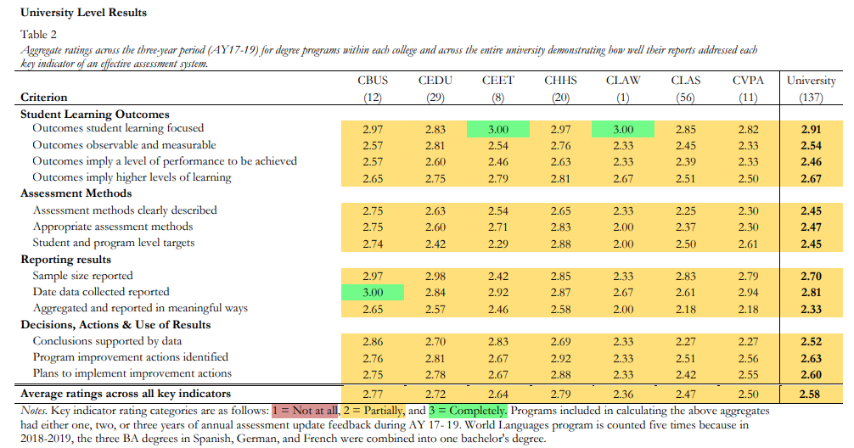
https://www.niu.edu/effectiveness/_files/annual-assessment-update-report-2016-2019.pdf
Insert Name of Assessment Method 2 that is used to gather information about Objective 1.2 here
Assessment-level Target: Insert target text here…
Assessment Method 2 Results
Insert results for Assessment Method 2 here…
Objective 1.2. Insert Objective 1.2 text here…
… repeat the same format for additional objectives
Synthesis of Goal 1
Insert analysis, synthesis, and conclusions for the overall goal and its objectives here…
Goal 2. Repeat the same format for additional goals
--------------------------------------------------------------------------------------------------------------------

3. Decisions, Actions, and Use of Results
This section of the status report is where you discuss how the unit used the reported assessment results for unit improvement purposes. In doing so, describe the decisions that were made and the actions that were taken. Comment on:
- what was done well,
- unit improvements that are needed,
- improvements actions that are planned,
- improvement actions that have been implemented, and
- how improvement actions that were planned and implemented are being assessed (making sure the improvement loop is actually closed).
The discussion should shed light on how the unit is proactively (and/or reactively) using assessment results to improve the unit.
Insert discussion of decisions, actions, and use of results here…

4. Appendices (All Assessment Instruments/Rubrics)
Include copies of instruments/rubrics for all assessment methods that are included in the assessment plan and status report. While it is recognized that some assessment instruments may be unavailable for inclusion, every effort should be made to include the actual assessment instruments the unit is working with. Assessment instruments will be securely stored and have limited distribution.

Thank You for your proactive and engaged support of quality assessment practices. If you have any questions concerning the assessment plan or the status report, please contact Accreditation, Assessment, and Evaluation (AAE) at rsubramony1@niu.edu.

SUBMIT electronic versions (MS Word) of the assessment plan, status report, and attached assessments to Accreditation, Assessment, and Evaluation (AAE) assessmentservices@niu.edu

