NIU Commencement Mobile Ticket Guide
(this is how graduates can access and transfer their tickets):
Use your MOBILE DEVICE to access your tickets.
- This includes a cell phone or tablet. Please do not try to access your tickets on a desktop computer as the user interface will not look the same.
Navigate to NIUHuskies.eVenue.net and click on Student Tickets
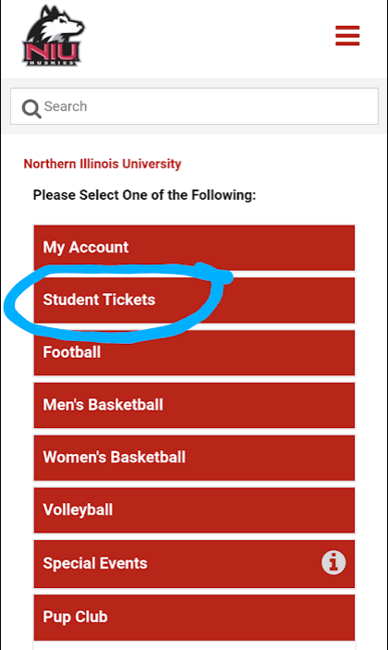

Click on “Sign In as Student” and you should be redirected to NIU’s website to log in with your NIU Z-ID and the password you use for NIU logins (blackboard, etc.).
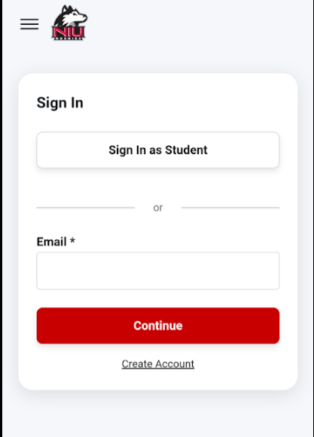

Once you have logged in to your account, click on the hamburger menu (the three lines in the top right of the screen) in the upper right hand corner and choose My Account.
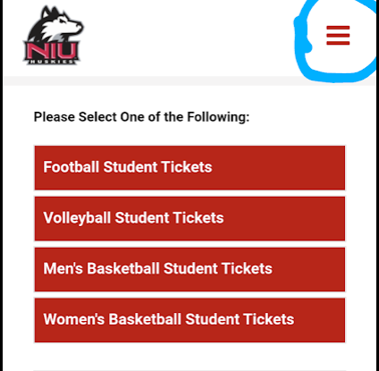
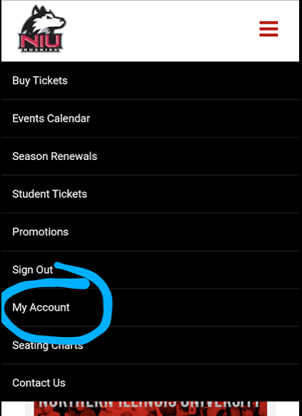
You should see your name and email at the top of the page. To transfer your tickets to your guests click on Transfer Tickets from the menu below your name and email.
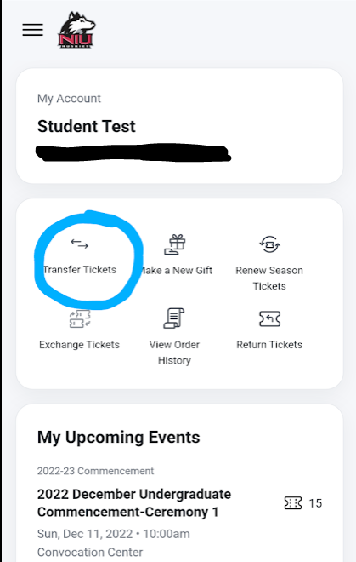

Please DO NOT click on My Upcoming Events and download the tickets to your Google/Apple wallet at this time unless YOU will be scanning the ticket on commencement day. Your guests will need to download the tickets to THEIR wallet once they have received them. You must transfer the tickets to them through your account first, and they will download the tickets to THEIR wallet later.
After you have clicked on Transfer Tickets you will see your graduation event. Click on the event.
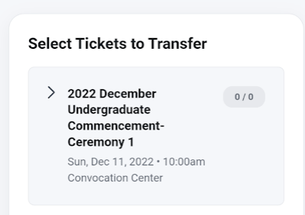
You will now choose which tickets to transfer to each guest. All tickets are general admission within the Convocation Center arena. If multiple guests are arriving together you may send multiple tickets to the same email address and they can scan them all off of one device when they arrive. An example of this is if your mother, father, and younger sibling are all coming together. You can send all three tickets to your mother, for example, and event staff will scan all three tickets off of her phone when they arrive.
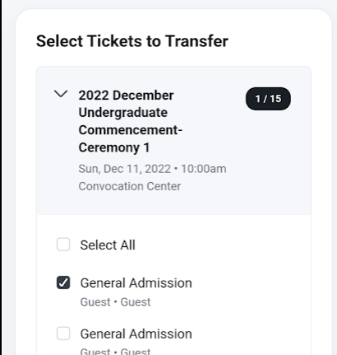
Please note that once a ticket is transferred and has been accepted by the receiving party, you will no longer be able to access that ticket from your account and the recipient must now access the ticket through their account.
Enter the name and email of the recipient you want to send the ticket to and click Review Transfer
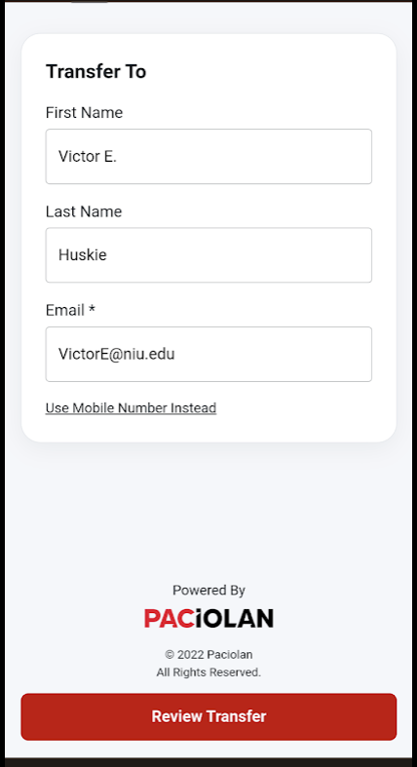
You will see the name, email, and number of tickets on the review screen and if that is correct. Click Transfer Tickets at the bottom of the screen.

How your guests will access their tickets:
Your guests MUST BE USING A MOBILE DEVICE to access their tickets. Your guests will receive an email from no_reply@paciolan.com entitled “YOUR NAME wants to send you # ticket” with YOUR NAME replaced with your name and # replaced with the number of tickets you’re sending. When they open the email they will click Accept Transfer.
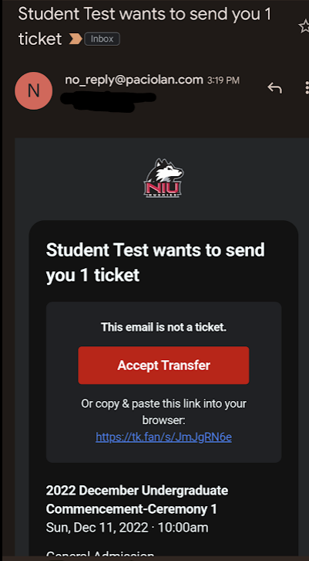
They will then be prompted to sign in. If they do not have an account they will need to create one. If they already have an account they can click “Forgot Password” and get a temporary password via email to access their account.
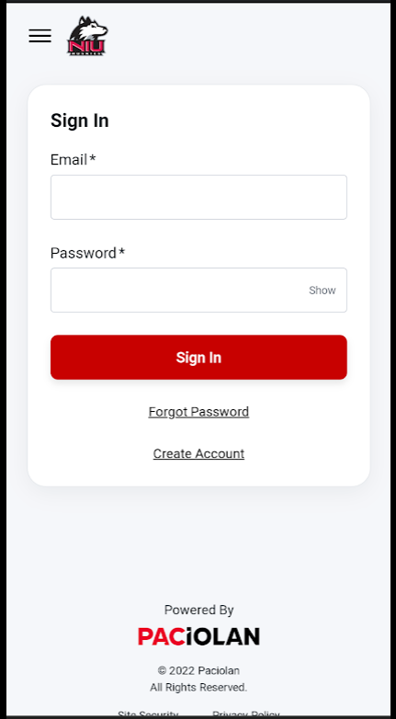
Once they have created their account or logged in, they will be prompted to download the tickets to their mobile wallet (Google Wallet or Apple Wallet). Click this link to download the tickets and access the barcodes.
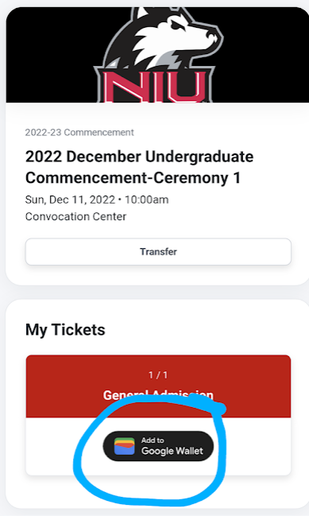
They will then be redirected to their mobile wallet app (they may need to sign in or create an account) and will click “Add” to add the ticket to their mobile wallet. They can now access the ticket/s DIRECTLY from their device. They do not need to log in to their account and will not need to rely on the wifi at the Convocation Center on the day of the commencement event. They simply open the wallet app on their phone and the ticket barcodes will be there to click on. The Apple Wallet and Google Wallet app icons are below. If they do not have an Apple Wallet or Google Wallet app. Both are available on the App Store or Google Play. Downloading tickets in advance is VERY IMPORTANT as wireless internet at the Convocation Center can get overwhelmed if many people are attempting to log on to their online account once they arrive.
