NORTHERN ILLINOIS UNIVERSITY

PHYSICS DEPARTMENT

Physics 374 – Junior Physics Lab Spring 2022

Python Tutorial #1

Installation of Python

The version of Python used in this Tutorial is Python 3.7. The integrated development environment (IDE) that is used is Microsoft Visual Community 2022. MAC users are recommended to install Microsoft Visual Code as the IDE. Installing Microsoft Visual Community is free will also install Python.

Do a Google search for Microsoft Visual Community and install it by selecting the following additional features (they are not installed by default): (1) Python development and (2) Desktop development with C++. If desired, you can install other packages (like the Visual Basic package selected below).
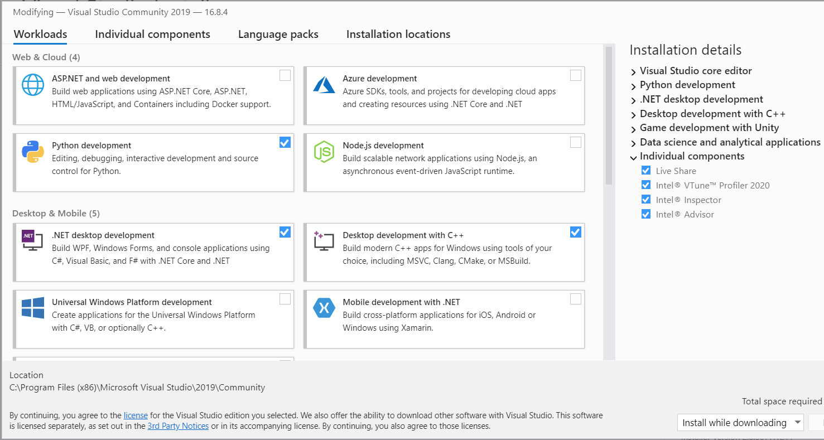

Python is a dynamic language (executed by an interpreter) that cannot be compiled into machine code statically (like C++ and Fortran). Python 3.7 is an interpreter that is needed to execute Python commands.

Fortunately, pip is installed automatically when Python 3.7 is installed. If pip is not installed, go to: https://pip.pypa.io/en/stable/installation/. If you get a warning that a newer version of pip is available and that you should upgrade. To do this, click on the Start button and type “powershell” and select the Windows PowerShell application. In PowerShell type:

py -m pip install --upgrade pip

If you get a warning that a Python Scripts directory are not on PATH, add the directory to PATH by editing the system environment variables. Documentation can be found at:

https://www.architectryan.com/2018/03/17/add-to-the-path-on-windows-10/

To add the Scripts directory to PATH: (1) click on the Start button and type “env”, then select “Edit the system environment variables”, (2) select the “Advanced” tab, (3) click the “Environment Variables…” button, (4) Under the “System Variables” section (the lower half), find the row with “Path” in the first column, and click “Edit…”, (5) click “New” and type (or copy and paste) the new path. For instance, it should look similar to:

C:\Users\UserName\AppData\Roaming\Python\Python37\Scripts

depending upon what your “username” is. You can always find out which directories are in your PATH by typing: $env:PATH in your PowerShell window.

Writing Code in Python

Now that Python and PyInstaller have been installed, we can now start writing Python code. Start the Microsoft Visual Studio application and click “continue without code”. Click on “File” “New” “Project…”. Under “All languages” select “Python”. Then select the “Python Application” row, and then select “Next”. Name the “Project name” as “Hello World”. Select the Browse button to put the project in a directory of your own choosing.

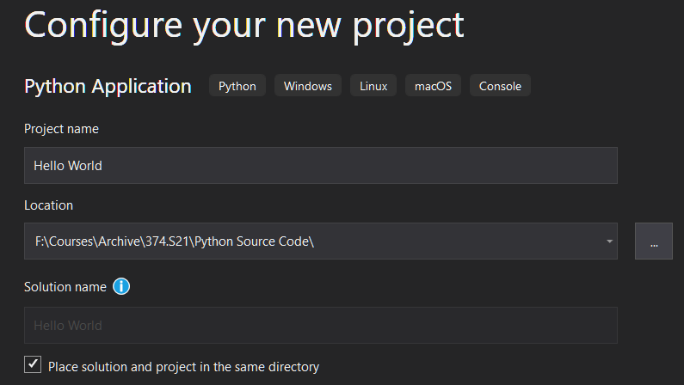

Browser button to select location of project

Then select “Create”.

In the Hello_World.py window, type: print("hello world")

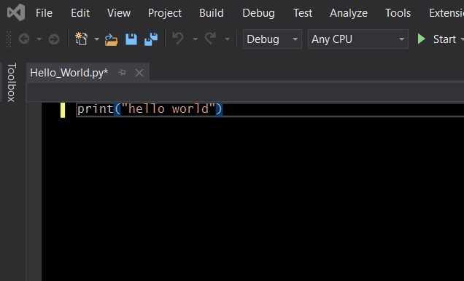

“Start” button runs the code

Click on the “Start” button (green arrow triangle), and a console window should appear with the phrase “hello world”. You have now written your 1st Python application. If you go to the folder where your Python code lies, you should see the following:

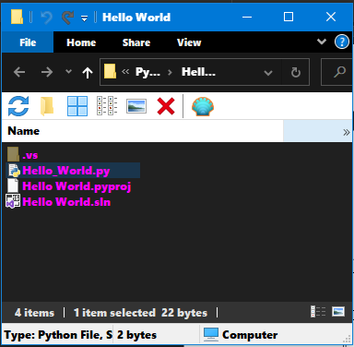

The *.py file is the source code, the *.sln file is the Solution file (containing the project). Double clicking on the Solution file opens the Python project.

Notice that the console window simply flashes and then disappears. We need a way to force the window to stay on the screen until we wish to close it. We can do this by typing the line, “input()”, below the line “print(“hello world”):

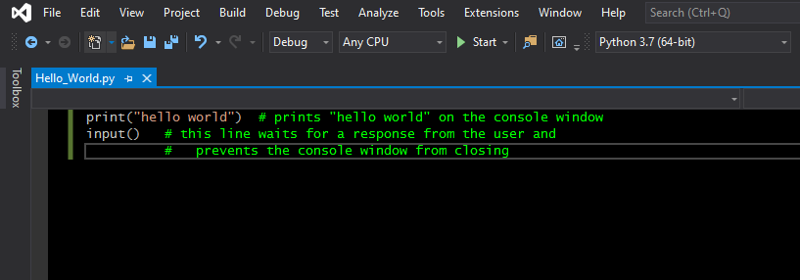
The input() function is waiting for the user to press the carriage-return (or enter) key to continue running the program.

Writing Python GUI with Tcl/Tk PyQt5

The previous section showed how to write code for command line applications that rely on a console for operation. In this section we will write code that uses the window environment of Windows, Mac, and Linux operating systems. Thus, we will write a windows-driven rather than a command-line driven program using the widgets available in the Tcl/Tk package called tkinter. There is a good tutorial on the web located at:

https://learn.sparkfun.com/tutorials/python-gui-guide-introduction-to-tkinter/hello-world

Read Shawn Hymel’s tutorial called “Python GUI Guide: Introduction to Tkinter” on the webpage above. The code below is based on his tutorial. Create a new Python program called Hello.py, and copy and paste the code below and run it:

import tkinter as tk # import the tkinter module (or package)

root=tk.Tk() # create a root window (the main window of this program)
root.title("My first GUI program") # provide a title to this window

a = tk.Label(root, text="Hello World!") # create a Label widget (a text box)
a.pack(padx=200, pady=20) # make the text box 200 pixels wide and 20 pixels high

root.mainloop() # start the program and wait for commands

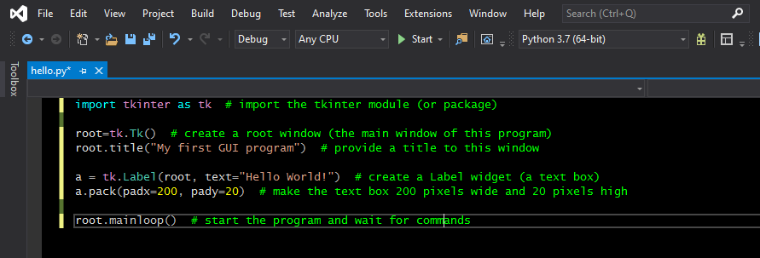

Upload to Blackboard your source code (*.py) of your Python programs Hello_World and Hello. You will see an assignment on Blackboard called Python Tutorial #1.

